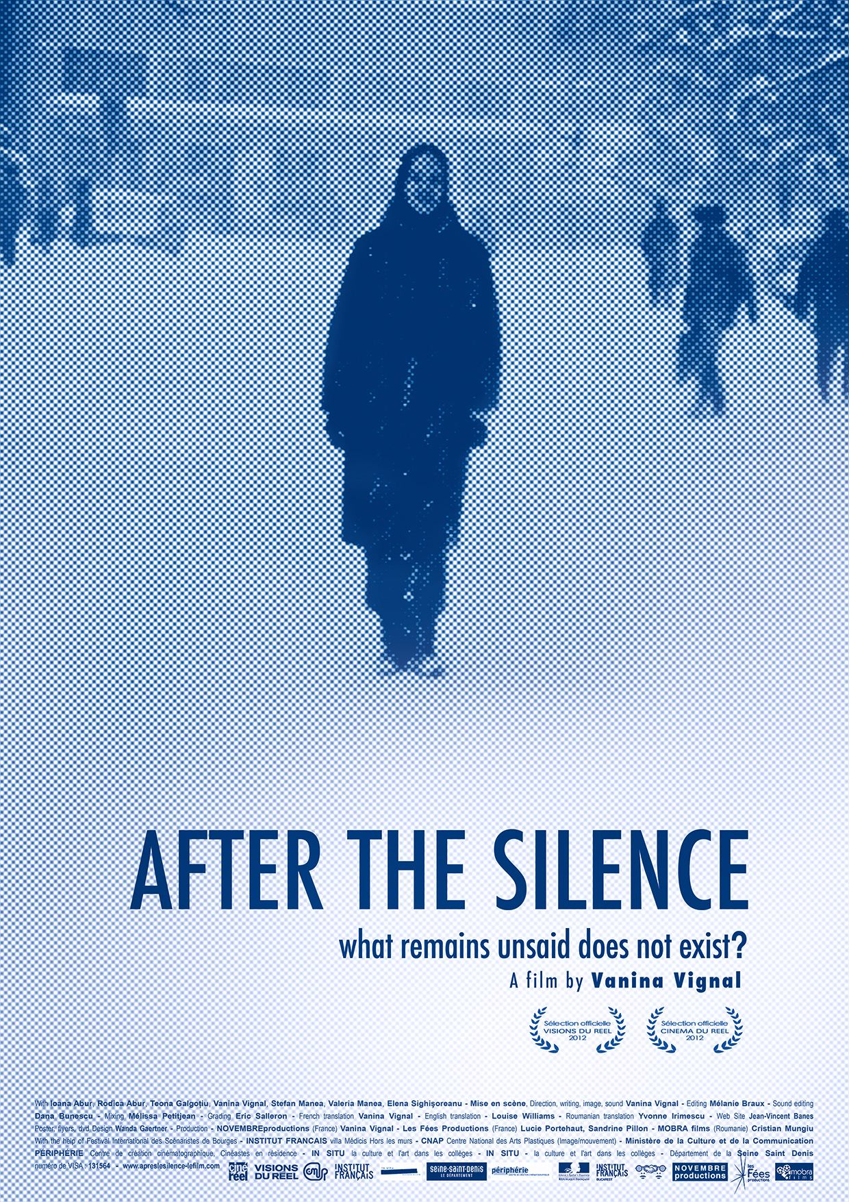

20/04/2012

How do we carry on living, afterwards.
When we've grown up under a dictatorship, when we shaped our lives under a dictatorship. When it's part of us.

Second part of a trilogy about Romania after STELLA
patrimony award at the 2007 cinéma du réel:

AFTER THE SILENCE what remains unsaid does not exist?

APRES LE SILENCE ce qui n’est pas dit n’existe pas ?
DUPĂ TĂCERE ceea ce nu e rostit nu există?

A film by Vanina Vignal

Cinéma du réel 2012
International documentary film Festival - Paris - France
Visions du réel 2012
International Film Festival - Nyon - Switzerland

Documentary feature film - 96’ - march 2012 - VISA n° 131564
a Franco-romanian production
© NOVEMBREproductions - Les Fées Productions - mobra films - 2012

Facebook - http://www.facebook.com/ApresLeSilenceAfterTheSilenceDupaTacere
Web-site - http://www.apreslesilence-lefilm.com
Email - apreslesilencefilm@gmail.com

NOVEMBREproductions
Vanina Vignal
6 bvd Henri IV - 75004 Paris - France
novembreproductions@live.fr
vvignal@free.fr
Tel/fax +33 1 40 05 94 68 - Gsm +33 6 60 52 03 82
http://www.stellalefilm.com

Les Fées productions
Lucie Portehaut and Sandrine Pillon
9/11 rue Benoit Malon - 92156 Suresnes - France
lesfeesproductions@gmail.com
Gsm + 33 6 12567399
www.lesfeesproductions.fr

Mobra Films
Cristian Mungiu
5 intrarea Serdarului - 011377 Bucharest - Roumania
cristiana@mobrafilms.ro
Tel + 40 21 666 48 27
www.mobrafilms.ro
Contact - Cristiana Mitea

Intention

How do you carry on living, afterwards? Killing the dictator doesn’t necessarily kill the dictatorship.

Totalitarianism is a system founded on blind obedience, terror and violence. Anyone who lives for too long under such a system will, involuntarily, eventually, become part of the system. It’s an underground terror that reigns, it becomes part of one’s life, a banal habit.
The unacknowledged victim has two options: to refuse reality and carry on as a victim of History (even unconsciously); in doing so, to maintain a connection with such historical injustices and, as a result, is forever caught up in the trap, or, to try and understand the chain of events so as to come to terms with the fact it happened. Then to forgive in order to unravel the bond that ties us to that historical injustice and the perpetrators. Radu Clit, Psy. D, University Paris 5. “Totalitarian Frame and Narcissistic Functioning - collective and individual psychological effects of East European communist state power”.

I agree with Radu Clit. In my opinion, it concerns state controlled dictatorships just as much as domestic dictatorships. There are many different kinds of perpetrators but the effort that’s required to undo the ties that binds us to those perpetrators is the same. That work depends on us, we have to set it in motion.

I met Ioana in 1991, in Bucharest, a year after the coup d’état that the media called the “Revolution”. When we met, we talked about everything except the dictatorship from which her country had recently emerged, as if silence could expunge everything that was still too raw.
After my studies in Bucharest, I returned regularly to visit Ioana and her family, with whom I’d created strong family ties - I became the godmother of Ioana’s daughter, Téona, and Rodica, Ioana’s mother, had become like a substitute mother to me. I understand their country’s problems “from the inside”. Now I personally feel them.
It helped me work on the subjects of abuse, silence and fear, on the cocoon that Ioana made for herself - an illusory cocoon that preserves her from the surrounding reality and protects her from the abuse, both present and past, for the old, intrusive reflexes die hard in Romania, and Ioana, powerless and depressed, has withdrawn into her family unit. She refuses the reality of the outside world in which she lives - she involuntarily maintains a connection with the historical injustice - her cocoon has become a cell.

Ioana has never taken the time to analyze what torments her. Words have only come to the surface because they are inscribed in a filmic endeavor which supports and transcends them.
The editing accentuates these dynamics, so that people who have never discussed their traumas can, at last, “answer” each other. It thus stresses the silence and the unspoken, which still keeps them apart, and which has been passed on from generation to generation. It already surrounds Téona who has understood without needing to be told that certain questions should not be asked of her elders, exactly like her mother understood long before her.

Through the story of Ioana, a young, 40 year old Romanian woman, my film shows how living under a dictatorship becomes a way of life. (Et cela, ce n’est pas l’apanage des pays ex-communistes) And this is not the « privilege » of ex-communist countries.

Vanina Vignal, march 2012

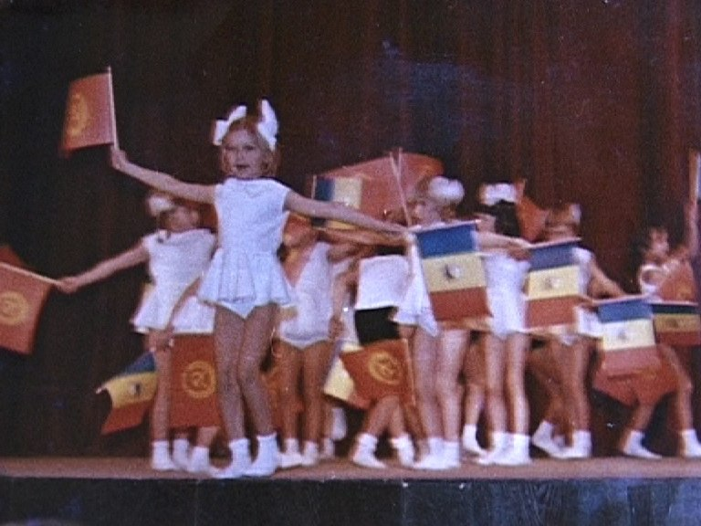

AFTER THE SILENCE deals with how the effects of dictatorship are still extremely vivid, even after the fall of dictatorship. It is a film about the abuses of the state, about fear, how silence is passed on from one generation to the next. A film about the space which, despite all that is known, is left to ghosts that make it impossible to live fully in the present. Three generations walled in silence. The legacy of denial, as nothing has been put back in its place and nothing has been said. Killing the dictator is not enough to kill the dictatorship. Vanina Vignal

Cinéma du réel 2012

“It was normal: Ceausescu, the RCP, we lived with it, why talk about it?”. When Vanina Vignal met Ioana in Romania in 1991, the dictator had fallen but the two friends still avoided politics. AFTER THE SILENCE is constantly battling against the silence transmitted from generation to generation in her friend’s family - and the whole country. Armed with a dictionary, her fluent Romanian and an intimate knowledge of the family, the filmmaker shows rare determination in an established documentary genre - the evocation of the abuses of a dictatorship - that sometimes goes no further than gathering testimonies. For the sake of their friendship, she asks questions relentlessly, digging into a half-revealed family secret and testing the small private world that Ioana has retreated into. And the more the conversation progresses, the more her Romanian friend details the strategy she developed during the dictatorship in order to avoid politics. This survival-driven apolitical attitude soon reveals itself as what fuels the system, which is only too happy that brains disconnect of their own free will.
Charlotte Garson

VISIONS du réel 2012

Vanina Vignal returns to Bucharest to film her childhood friend, an actress who stayed and lived under the Ceausescu regime. Ioana’s confession highlights the complexity of a person’s relationship with a repressive society and its leader, whose ghost still sometimes seems to be hovering in the background: killing a dictator is not enough to put an end to the legacy of his reign.

Short summary (Cinéma du réel 2012)
Twenty years ago, the filmmaker struck up a friendship with Ioana in Romania. She returns to ask her about family silences. Together, they analyse a powerful and despotic mechanism: the perpetuation of denial.
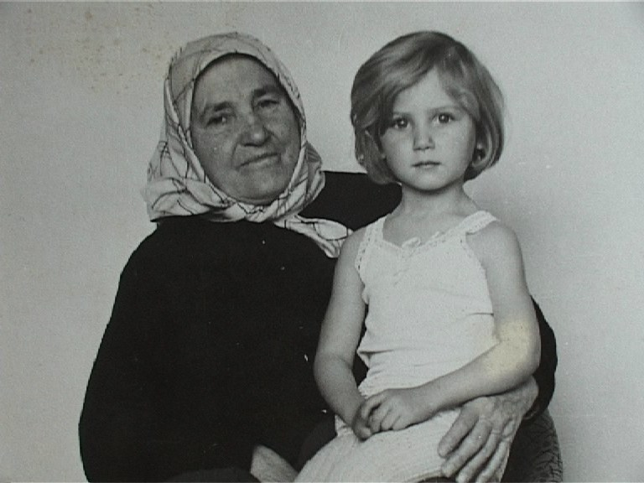
Shooting format - DV and Hi8 - 16/9 (4/3 in 16/9)
Screening format - Beta digital pal - Stereo
Languages - Roumanian, French, English
Subtitles - English or french or roumanian

Technical list
NOVEMBREproductions Vanina Vignal
Les Fées Productions Lucie Portehaut, Sandrine Pillon
MOBRA films (Romania) Cristian Mungiu
Direction, writing, image, sound Vanina Vignal
Editing Mélanie Braux
Sound editing Dana Bunescu (bucharest)
Mixing Mélissa Petitjean
Grading Eric Salleron
Mobra films office manager Cristiana Mitea
NOVEMBREproductions accountance Jean Berthelemot
gérante de NOVEMBREproductions Jacqueline Tuffelli
French Translation Vanina Vignal
English Translation Louise Williams
Roumanian Translation Yvonne Irimescu
Web Site Jean-Vincent Banes
Poster, flyers, dvd Design Wanda Gaertner
With Ioana Abur, Rodica Abur, Teona Galgoţiu
Vanina Vignal, Ștefan Manea, Valeria Manea,
Elena Sighişoreanu
With the help of
INSTITUT FRANCAIS villa Médicis Hors les murs - CNAP Centre National des Arts Plastiques (Image/mouvement) Ministère de la Culture et de la Communication - PERIPHERIE Centre de création cinématographique, Cinéastes en résidence - IN SITU artistes en résidence la Culture et l'Art dans les collèges Département de la Seine Saint Denis Festival International des Scénaristes de Bourges
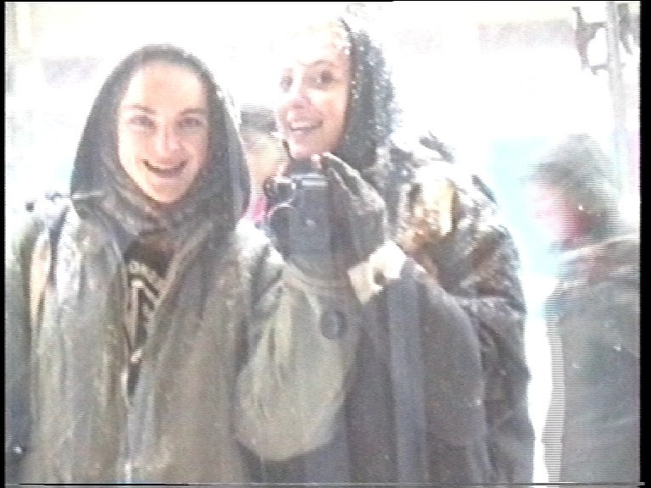

Vanina Vignal’s Biography

“Because of my films, people often think I have Romanian origins, which I haven’t. But there have been important random connections with this country. I met a Romanian woman who had fled her totalitarian country. Among her exiled fellow countrymen, a playwright, who said to me: “When this play is produced, I want you for this part.” He did not forget his promise and his play was staged at the Vasile Alexandrii Theatre of Iasi, in Romanian Moldavia.
The neighbour was still the Soviet Union, and fragile Romania was shyly opening up to the world after a speedy “revolution” the country had had no time to digest - which was in fact a coup d’état. It was around this time I first came into contact with Romania, where I arrived bringing with me all the clichés the media had been feeding us since December 1989. It was a tremendous shock. The better I understood the lives of the people around me, the less I knew about this country; my convictions about Eastern Europe were steadily shattered…”. Vanina Vignal

Vanina Vignal was born in France. She trained as an actress at the Jacques Lecoq International School of Theater and Movement, and the National Theatre Conservatory of Romania. She has worked extensively in theatre, which has given her a subtle perception of drama embedded in people’s everyday lives. She then trained as an assistant editor and assistant director, before turning to her own projects. Among other things, she speaks fluent Romanian, which gives her direct access to the people she has chosen to film.

Vanina Vignal’s Filmography

STELLA (“Prix du Patrimoine” at the Cinéma du Réel - 2007) was Vanina Vignal’s first film as a director NOVEMBREproductions - http://www.stellalefilm.com
AFTER THE SILENCE is the second film of a Romanian trilogy : after Stella, which deals with the working class, this film focuses on the lower middle class, and the THIRD FILM will be about the ruling class that was ousted in 1948. It will be shot in Bucharest with people from “impure social origins” (as they were branded by Romanian leaders from 1948 onwards), who were stigmatized by the new leaders and yet didn’t choose to go into exile but built their lives within this new reality - in the Romanian People’s Republic.

wednesday 4 april 2012
http://independencia.fr/revue/spip.php?article527
Healing the wounds… of those who are not dead.
by Mr Camille Brunel (english translation : Alexis Tadié)

Vanina Vignal speaks : ‘If there are empty seats beside you, let us know ! There are people who can’t get in !’ This film is close to her heart: she records the testimony of a childhood friend who grew up under Ceausescu. This is, as ever, the quest of what lies hidden in an eye. Where is the dictatorship, where are its aftereffects, in the green eyes of this beautiful young woman of 40, who is being interviewed here, who appears, there, as a teenager, in old family films which have been dug out of the past, and interrupt the sequences of remembrance ? Where is the dictatorship in the eyes of the young woman who kisses Kevin Costner, on a handful of photographs, in 1985 ? There is also this moment when an old photograph takes over the cinema screen: it shows a tired old granny, holding a young girl in her lap. It is a long, still shot. Four eyes on screen, two hundred eyes in the auditorium. Staring at each other. The effect is close to that produced by the eyes of animals in Denis Côté’s BESTIAIRE (cinéma du réel festival, 2012). We feel looked at, deeply. Something is happening, something touches us. Silence is total. These four eyes have seen the dictatorship. Vanina Vignal interrogates this sad strangeness. She is never taken in by what is not said; behind the speakers, a mirror often reminds us of the dark side that is always there. Eyes are the true heroes of this film – the still photographs of the vacant eyes of a grand-father who survived forced labour, or the eyes of a heroine marshalled into a propaganda film. This, perhaps, would be overwhelming in another context, but not in AFTER THE SILENCE, which is a true treatise on eyes and gazes.
AFTER THE SILENCE shuns political discourse. At most, it mentions the ways in which the Rumanians did not talk about politics when it was an open wound. There is the fascinating interview of a young teenager in 2012 ; in order to free herself from the past, she does not talk about politics either. There are therefore three types of silence: the silence of those times, the silence of testimony, the silence of the young girl. Or again: silence in the past, in the present, in the future, always with the same purpose, to avoid touching the wound. After the end of dictatorship, the Rumanian people has kept on complaining, says the young woman. Because they were unable to take their lives into their own hands, individuals were not happier when they won this freedom which they did not know how to handle. In the last shot of the film, two identical women follow each other. Two ways of living. Two clones. Last week’s motifs of the festival keep crowding in. How can we not think of the passivity of the inhabitants of Corbeil-Essone, in Julien Meunier’s La Cause et l’usage (cinéma du réel festival, 2012), individuals without politics, pleased because they have a little father who takes them by the hand, and who are content with a simulacrum of democracy.

wednesday 18 april 2012
http://cinemadocumentaire.wordpress.com/2012/04/18/apres-le-silence-vanina-vignal/

AFTER THE SILENCE what remains unsaid does not exist?
Article by Ms Camille Bui
(english translation by Alexis Tadié)

We enter the film from the sky. Against the dark blue of the sky, the clouds are scattered and brought back haphazardly by the wind. The moving sky, which is initially silent, welcomes the first words:
« - Do you remember speaking to mum about it ? Your Mother? - We haven’t really talked about it, no. - And with Teona? - No, not with Teona, Teona doesn’t know much about history… you know, the communist period.” This snippet of dialogue between the director and her friend Ioana introduces the question of the silence, that instrument of dictatorship around which the film is built. The game of questions and answers which unfolds between the two women throughout the film is one way of breaking the silence, by pointing to, and turning upside down, the apparent void that silence has left in memory and in the transmission between generations. Vanina Vignal’s film interrogates the possibility of bringing up what is unsaid and to (re)build links that were damaged by the necessity of remaining silent, in order to survive, both psychologically and physically.

AFTER THE SILENCE was born of a friendship between Vanina Vignal and Ioana Abur. They met in Bucarest in 1991, shortly after the fall of Ceaucescu. The director’s perspective is born out of this relationship. She questions Iona’s story from the position of a friend. AFTER THE SILENCE is the material and the medium of a dialogue between Vanina Vignal and three generations of Rumanian women: Iona, her mother Rodica, and her daughter Teona. Vanina Vignal is a stranger to Communist Romania, so that her position is both intimate with, and at a distance from, History and the women she records. She constructs her film from this singular position, a position which is figured by her position as a speaker in the film, but she also speaks through a voice over which accompanies the spectator, in a discrete and persistent way throughout the film. The voice over “takes charge of the analysis which the characters always refused to produce” but it refuses to be “a god who would know everything, as opposed to the characters who don’t”. She speaks from her own, humble, position, her knowledge is different from that of the characters, it is built from the outside, through meetings and empathy.

The film opens with a picture of Vanina and Ioana, in 1991, their own reflection framed in a shop window, under heavy snow. Vanina films Ioana. From these images of the past that were shot in Hi8, the film takes us towards present day Romania. Before the shot of the sky, we read the fragile subtitle “what is not said does not exist?” Then, facing the camera, in 2011, Rodica, Ioana and Teona express in turn the difficulty they have of remembering, of thinking about, of talking about the communist period. At the heart of their narrative, we perceive silence, fear and the unsaid, which are like traces of the totalitarian regime, almost like a negative film. Progressively, we understand that Rodica carried the weight of her father’s arrest, who was deported as a prisoner, in order to work on the massive building site of the canal which now links up the Danube to the Black Sea. This piece of engineering relied on the work of thousands of men, many of whom lost their lives in the process. Ioana, Rodica’s daughter, was always kept ignorant of the reality of Romanian politics by her parents who wanted to protect her. She was told a transformed version of the history of her grand-father, a story which she, in turn, has not questioned. Teona, Ioana’s daughter, is not terribly interested in history and would rather not talk about Ceaucescu. The film and the questions raised by the director bring back the past to the mutilated present of the lives of these women. If ever Vanina’s questions do not bring back the past to the present, official definitions in a dictionary of the communist period do so. On Ioana’s face, emotion can constantly be seen - she is in turn overwhelmed by a surfeit of memories or, on the contrary, something in her shuts down, in a defensive refusal to think. Throughout the film, Vanina Vignal follows Ioana’s emergence from the bubble of silence which had been built around her, at a moment in her life when she wonders about what she has received from her parents and about what she passes on to her daughter.

The broken interviews with Ioana, but also with her mother and her daughter, yield few clear lines in their family history. What is felt through words is more subtle than a list of forgotten facts which are later unearthed. The film records the ways in which the aftereffects of the silence, as well as of the oppression it fostered, leave a mark on a body, on a face, in a mind. The true event in the conversations lies in the words that emerge from the bodies after having been censored and stifled for decades. Throughout the film, Ioana is engaged in a physical struggle to overcome the difficulty of emerging from the silence. Silence seems to be inscribed in her body. Vanina films her face, her eyes. The frame of the picture is the interface between the faces of the two women. The organisation of the bodies in a shot/reverse shot system defines the form of dialogue between them. The director says: « In Ioana’s life, I am someone who disturbs, who questions ». In the cinema, Vanina places Ioana in front of her camera and of her microphone.

As a counterpoint to these pictures of 2011, Vanina Vignal introduces short films that she shot with a Hi8 camera twenty years earlier. Ioana is seen as a happy teenager. This apparent carefree attitude is echoed by Vanina’s spontaneous, amateur filming. The film is thus built on a complex movement between pictures from the past - when silence was not ready to be undone - and the images of the present, which are visually more austere, more direct in their frontal construction. This to and fro movement between two eras of Romania and between two phases of the relationship between the two friends allows us to measure the distance separating the past from the present. It is sensitivity that makes us understand what separates the smiles of yesterday from the emotion that accompanies the moment when silence is finally broken. The pictures of the past which are seen with the eyes of the present show the difficulty of a genuine communication when what was unsaid was denied. Conversely, the pictures of the present, which are seen between pictures of the past, are heavy with the weight of a silence from which Ioana is trying to emerge. The juxtaposition of both sets of pictures is thus a way for the film to generate a link between the past and the present, a condition for understanding history. These shots that were made by the director between 1991 and 2011 are supplemented by other pictures. Children or family photographs, accompanied by Iona’s or Rodica’s commentaries, immerse us in the uncanny of Barthes’s “it-was-once”: this little girl, the man or the woman in the picture have lived through the horrors of the dictatorship, in their most intimate everyday lives. Elsewhere, Vanina Vignal introduces the beginning of a propaganda film, in which Ioana featured, as a teenager. When Ioana starts speaking in the “Young Rumanian Socialist”, the film stops on her face, and the director’s voice takes over to deflate the discourse of propaganda, which is another way of restoring the link between a past immersed in lies and the beginning of the end of silence.

Through the grouping of these heterogeneous pictures, a multifaceted dialogue is constructed by the editing process, between the camera-holding director and three generations of Rumanian women, but also between two stages of the end of the communist regime in Rumania, since “it is not enough to kill the dictator to kill dictatorship.” Thanks to dialogue, between pictures and people, the film brings out everyone from their own inner silence. Cinema enables the painful past to exist in the present, in order better to face the future. Without imposing a dialogue between generations, Vanina Vignal hopes it will happen, and she shows the first signs of it. She stays with the characters from the end of silence to the beginnings of discourse. This discourse is still fragile, wondering about its own possibility, but it interrupts the transmission of silence. With AFTER THE SILENCE, Vanina Vignal gives birth to action in speech.

1. Vanina Vignal, Interview published in the Journal du Réel, N° 1, March 2012. Available on line http://blog.cinemadureel.org/2012/03/22/journal-du-reel-1-apres-le-silence-ce-qui-nest-pas-dit-nexiste-pas
2. Idem.
3. The film The Young Romanian Socialist was directed by Cornel Diaconu in 1985 in the studios of the Centre for Cinema Production in Bucarest (Casa de Filme 1). Cf. trailer of After the Silence.
4. Vanina Vignal, Author’s note.
Available on line http://www.apreslesilence-lefilm.com/presentation/note-dintention-2/
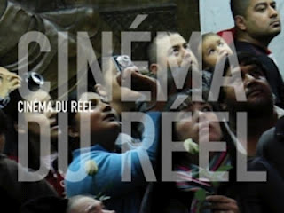

Journal du Cinéma du Réel 2012
http://blog.cinemadureel.org/2012/03/22/journal-du-reel-1-apres-le-silence-ce-qui-nest-pas-dit-nexiste-pas/
Interview conducted by Lucrezia Lippi and Sébastien Magnier
(english translation : Hélène Tison)

With the faces of yesterday and today, with voices that do not meet, Vanina Vignal sketches out a journey within this Roumanian family, to whom she is so close, so that the truths about a trauma may come to the surface at last.

AFTER THE SILENCE, to some extent, almost seems to be about friendship rather than history or memory.
You could say, at the least, that friendship is what carries the film along. If it hadn’t been for the friendship, I wouldn’t have gone “digging” and without the two of us, maybe you wouldn’t have been interested in finding out what was behind it all. In Iona’s life, I’ve always been somebody who stirs things up, who asks questions, I’ve always helped her go beyond her limits. It’s been the basis for our friendship for twenty years, and gradually, it became the film: a journey toward what is concealed behind the family myth and the country’s history. Iona didn’t succeed in completing that journey on her own, it was too painful. But she found the strength to do it with me.

Is this, generally, the type of relationship you build with the people you film?
Let’s say that I’d find it hard to film the enemy. Some people can, but I know I couldn’t, even though I don’t pass judgement. Personally, I need to feel empathy, which doesn’t mean there are no conflicts. But we do things together.

Was the 1991 footage the starting point for the film? Why did you film then?
Because I’d stolen my father’s Hi8 camera; he’d received it for his wedding, but he wasn’t using it. So I just started filming at random all the time. I’ve always felt the need to keep track of things, and to look around me through a lens. At the time, I didn’t even watch what I’d shot. I was afraid of ruining the film. I thought I had to keep it for later. I was mailing things to myself for the future.
How did you decide on the structure of the film?
We played it by ear for a year with Mélanie Braux, my film editor, because there were a lot of different films we could have made with all that we had. What I was really interested in was how they thought, and how they managed, or didn’t manage, to say things. It was obvious that Iona’s voice couldn’t be cut up, that it had to exist over time, in the silence also; it needed time. It wasn’t so much what they said that mattered to me, but how. When we watched the first « draft » of the film, it became clear that my character (myself) had to be given more substance so that spectators could make connections. This meant that I had to be more present in the film.

Your voice over is quite present.
It was very hard to develop; that’s what took us the most time: depending on what I said and depending what the characters said, all of the balance of the film changed. We needed this voice over, because it takes responsibility for analysing what the characters have always refused to analyse. But we didn’t want it to be a sort of deity that knows everything while the characters don’t. It had to be a subtle accompaniment. It was quite difficult - as it was for me to accept the idea of being so present in the film. But the necessity became obvious at one point, so we took the time to do it. As I said, there are films for which time cannot be spared.

Three generations appear in the film, three different periods of time for a memory. Surprisingly, it’s Rodica who seems to find it easiest to talk, as if she needed to come out with certain things, too.
As soon as I asked her to tell me about her childhood, without knowing what had happened to her, Rodica just poured out all that she had been unable to tell her daughters.
I think my position, both inside and outside the family, my position also as a French person, who hadn’t known that world, communism, etc... it was the starting point for the film with these three women.

Teona is quite straightforward when she says she’s not interested in the topic.
Yes, but she also says that she’s « dying to ask » certain questions... So she’s understood, without ever being told, that she shouldn’t talk about these things. That’s the power of secrets and denial. When I started making the film I had intended to include three generations : I was instinctively going in that direction. Because what I’m dealing with here is how a secret is passed on from generation to generation.
When I came up with the title, “After the Silence”, I thought that it wasn’t quite right somehow, because to me, these three women were still shrouded in silence. But in the end it’s a good title, because it’s the film that will make them come through to the other side of silence: their journey to the film as well as seeing it together.

Do you think the film will help them move forward?
Ioana made the film for her daughter, and so did I to some extent. I can’t claim to change things, I’m no god. But at one point I realised, with the editing, that these characters were going to have a conversation. So even just wanting to see the film together, even in silence, although by now they know what it’s all about, that should change something. In fact, something has moved already, because Teona has told me she wanted to study history...

You’ve chosen to end the film with footage from the past.
Some people found it hard to understand the last shot, they wanted to see the Bucharest of today. But to me, it had to be an image from the past, it was obvious. This shot is my answer to what Ioana says; it says that I agree with her: things have not changed. There may be all the modernity and consumerism, but things haven’t changed yet in people’s minds. And it’s quite normal. Working on what hurts at the scale of an entire country is complicated. It won’t happen by waving a magic wand.
